
QR Code-Based Secure Authentication System
A CAPSTONE PROJECT REPORT
A Capstone Project Report submitted in partial fulfilment of the requirements for the Course of
CSA5115 — Cryptography And Network Security
to the award of the degree of
BACHELOR OF ENGINEERING IN
CSE
Submitted by
Sweta R (192511408)
Under the Supervision of
Dr T Sangeetha
SIMATS ENGINEERING
Saveetha Institute of Medical and Technical Sciences
Chennai-602105
SEPTEMBER 2026

SIMATS ENGINEERING
Saveetha Institute of Medical and Technical Sciences
Chennai-602105
BONAFIDE CERTIFICATE
This is to certify that the Capstone Project entitled "QR CODE BASED SECURE AUTHENTICATION SYSTEM" has been carried out by Sweta R (192511408) under the supervision of Dr T Sangeetha, and is submitted in partial fulfilment of the requirements for the current semester of the BE CSE programme at Saveetha Institute of Medical and Technical Sciences, Chennai.

COURSE COORDINATOR | COURSE FACULTY
Dr T Sangeetha | Dr T Sangeetha
Professor | Professor
Computational Intelligence | Computational Intelligence
SIMATS Engineering, | SIMATS Engineering,
SIMATS, Chennai – 602105. | SIMATS, Chennai – 602105.

SIMATS ENGINEERING
Saveetha Institute of Medical and Technical Sciences
Chennai-602105
DECLARATION
I, Sweta R of the BE CSE, SIMATS Engineering, Saveetha Institute of Medical and Technical Sciences, Chennai, hereby declare that the Capstone Project Work entitled "QR CODE BASED SECURE AUTHENTICATION SYSTEM" is the result of our own bonafide efforts. To the best of our knowledge, the work presented herein is original, accurate, and has been carried out in accordance with the principles of engineering ethics and academic integrity. All sources, references, data, and other materials used in the project have been appropriately acknowledged. We further declare that the data, results, analysis, and findings presented in this report have not been fabricated, falsified, or manipulated. Any external tools, software, datasets, computational resources, or AI-assisted tools used during the project have been appropriately disclosed. We confirm that all applicable ethical, academic, institutional, and professional requirements have been duly followed throughout the planning, execution, analysis, and documentation of the project.

Place: Chennai
Date: 05th September 26

Signature of the Students with Names
Sweta R (192511408)

SIMATS ENGINEERING
Saveetha Institute of Medical and Technical Sciences
Chennai-602105
INDIVIDUAL CONTRIBUTION STATEMENT
Student / Reg. No. | Specific Responsibilities | Design & Development Contribution | Testing & Analysis Contribution | Report Contribution | Approx. Contribution (%)
Elakati Renu Sree (192511035) | User Registration | Registration & validation | Registration testing | Introduction, Module 1, Results | 25%
Tarunika S (192511024) | QR Code Generation | Secure QR generation | QR generation testing | Problem Statement, Module 2, Conclusion | 25%
R Sweta (192511408) | Encrypted QR Verification | Scan, decrypt, expiry & validation | QR verification testing | Literature Review, Module 3, Testing | 25%
Abinaya (19241161) | Login Authentication & Activity Log | Login and activity tracking | Authentication & log testing | Objectives, Module 4, Future Scope | 25%

Total contribution: 100% (equal contribution across all four team members, as no unequal division of effort was specified).

ABSTRACT
The QR Code-Based Secure Authentication System is designed to provide a fast, secure, and convenient method of user authentication using QR codes. Traditional username and password-based authentication can be vulnerable to password theft, guessing, and unauthorized access. This system improves security by combining user registration, QR code generation, encrypted QR verification, login authentication, and activity logging. First, users register their details in the system, after which a unique QR code is generated for each registered user. During login, the user scans the QR code, and the system decrypts and verifies the QR information while checking its validity and expiry. If the QR code is valid and matches the registered information, access is granted; otherwise, the authentication request is rejected. The system also records successful logins, failed attempts, and logout activities in an activity log, helping administrators monitor user access and identify suspicious activities. Encryption and validation mechanisms provide an additional layer of protection against unauthorized access and misuse of authentication data. The system reduces dependence on traditional passwords and provides a quick, user-friendly, and reliable authentication process. It can be applied in educational institutions, offices, secure web portals, attendance systems, and other applications requiring secure user identification. Overall, the proposed system demonstrates how QR codes and encryption techniques can be effectively combined to provide a modern, efficient, and secure authentication solution.During login, the user scans the QR code, and the system decrypts and verifies the QR information while checking its validity and expiry. If the QR code is valid and matches the registered information, access is granted; otherwise, the authentication request is rejected.

TABLE OF CONTENTS

Sl.  No | Title | Page  No
i | CERTIFICATE FROM THE SUPERVISOR
ii | DECLARATION BY THE CANDIDATE | III
Iii | INDIVIDUAL CONTRIBUTION STATEMENT | IV
iv | ABSTRACT | V
v | LIST OF FIGURES | VII
vi | LIST OF TABLES | VIII
vii | LIST OF ABBREVIATIONS | IX
1 | CHAPTER 1: Introduction | 1
2 | CHAPTER 2: Literature Review | 5
3 | CHAPTER 3: Engineering Design & Trade-offs, Sustainability,  Ethics, Safety, Risk & Security | 8
4 | CHAPTER 4: Implementation, Testing & Results, Project  Management | 17
5 | CHAPTER 5: Conclusion & Reflection | 25
 | References | 29
 | Appendices | 30

LIST OF FIGURES
Figure No. | Figure Name | Page No.
Figure 1.1 | Overall System Architecture | 11
Figure 2.1 | User Registration Process | 28

LIST OF TABLES
Table No. | Table Name | Page No.
Table 2.1 | Comparative Analysis of Existing Approaches | 5
Table 3.1 | Stakeholder / User Requirements | 7
Table 3.2 | Functional & Non-Functional Requirements | 8
Table 3.3 | Constraints and Applicable Standards | 8
Table 3.4 | Design Specifications | 9
Table 3.5 | Alternative Solutions Evaluation Matrix | 10
Table 3.6 | Trade-off Analysis | 12
Table 3.7 | Sustainability, Ethics, Safety and Security Evaluation | 13
Table 3.8 | Risk Register | 14
Table 4.1 | Resources / Technologies Used | 15
Table 4.2 | Tools / Software Used and Implementation Stage | 16
Table 4.3 | Test Cases and Acceptance Criteria | 17
Table 4.4 | Specification Verification Results | 17
Table 4.5 | Achievement of Objectives | 20
Table 4.6 | Team Roles and Contributions | 21
Table 4.7 | Individual Contribution Percentage | 21
Table 4.8 | Project Timeline / Milestones | 22
Table 4.9 | Budget Estimation | 22

LIST OF ABBREVIATIONS / SYMBOLS
Symbol / Abbreviation | Description
BST | Binary Search Tree
GUI | Graphical User Interface
AI | Artificial Intelligence
DS | Data Structures
O(n) | Order of n — linear time complexity
O(log n) | Order of log n — logarithmic time complexity
IEEE | Institute of Electrical and Electronics Engineers

CHAPTER 1 INTRODUCTION AND ENGINEERING PROBLEM

1.1 Background
Authentication is one of the most important security functions in modern computer and web-based systems. It is used to verify the identity of a user before allowing access to protected resources. Traditional authentication methods generally depend on usernames and passwords. Although passwords are simple and widely used, they can be forgotten, guessed, stolen, shared, or exposed through insecure practices.
The increasing use of online services has created a need for authentication systems that are secure as well as easy to use. Users expect authentication to be quick and convenient, while system administrators require strong protection against unauthorized access.
A QR code is a two-dimensional machine-readable code that can store information in a compact form. QR codes can be scanned quickly using smartphones and other camera-enabled devices. When QR codes are combined with encryption and validation techniques, they can be used as part of a secure authentication mechanism.
The proposed QR Code-Based Secure Authentication System uses a unique QR code associated with each registered user. The system consists of four major modules: User Registration, QR Code Generation, Encrypted QR Verification, and Login Authentication with Activity Logging. The system verifies the QR code before granting access and records authentication activities for monitoring.
The overall approach provides an alternative to password-dependent authentication and demonstrates the application of QR technology and security mechanisms in a practical authentication system.

1.2 Need for the Project
The project is needed because traditional authentication methods have several limitations. Passwords can be stolen, guessed, reused, or shared. Users may also choose weak passwords that are easier to remember but less secure.
The major reasons for developing this system are:
- To reduce dependency on traditional password-based authentication.
- To provide a quick and convenient authentication process.
- To protect authentication information using encryption.
- To prevent the use of invalid or expired QR codes.
- To detect unauthorized authentication attempts.
- To maintain records of login and logout activities.
- To provide better access control for protected systems.
The problem affects users, administrators, organizations, and service providers that need reliable identity verification. From an engineering perspective, the challenge is to balance security, usability, speed, reliability, and implementation cost.

1.3 Problem Statement
Traditional password-based authentication can expose systems to security risks such as password guessing, password theft, credential sharing, and unauthorized access. A secure authentication system is therefore required that can provide reliable user identification while maintaining usability and fast access.The engineering problem is to design and implement a QR code-based authentication system that securely registers users, generates unique QR codes, protects QR information through encryption, verifies scanned QR codes, checks their validity and expiry, grants access only to authorized users, and records authentication activities.The system must balance multiple requirements including security, speed, usability, reliability, data protection, and implementation simplicity.

1.4 Project Aim

The main aim of this project is to design and develop a secure, reliable, and user-friendly authentication system using encrypted QR codes for user verification and controlled access.

1.5 Project Objectives
• To design a secure user registration module.
• To develop a unique QR code generation mechanism.
• To implement encryption for protecting QR authentication information.
• To develop a QR code scanning and verification mechanism.
• To validate QR code authenticity and expiry.
• To implement secure login authentication.
• To record successful and failed authentication activities.
• To test the complete system under different authentication conditions.
• To evaluate the security, usability, reliability, and performance of the proposed system.

1.6 Scope

Included
- User registration.
- User information validation.
- Secure storage of user information.
- Unique QR code generation.
- Encryption of authentication information.
- QR code scanning.
- QR code decryption.
- QR code validation.
- Expiry checking.
- Login authentication.
- Logout functionality.
- Activity logging.
- Failed-attempt monitoring.

Excluded
- Biometric authentication.
- Hardware security modules.
- Large-scale enterprise identity management.
- Advanced facial recognition.
- Full production-level cloud deployment.

Assumptions
- The user has access to a QR scanning device.
- The authentication system and database are available during login.
- Registered user information is accurate.
- Encryption keys are securely maintained.
- The QR code can be scanned clearly.

Boundary Conditions
- Only registered users can be authenticated.
- Invalid or expired QR codes are rejected.
- Authentication is granted only after successful verification.
- User data must not be exposed unnecessarily.

1.7 Expected Engineering Outcome
The expected engineering outcome is a functional software prototype of a QR-based secure authentication system.
The system should provide:
- A user registration interface.
- A QR code generation mechanism.
- Encrypted authentication information.
- QR scanning and verification.
- Validity and expiry checking.
- Login access control.
- Activity logging.
- Successful rejection of invalid authentication attempts.
The final system should demonstrate that QR codes can be integrated with encryption and validation mechanisms to provide a practical authentication solution.

CHAPTER 2 LITERATURE REVIEW AND EXISTING SOLUTIONS

2.1 Review Method
The literature review was carried out by studying existing authentication technologies, QR code applications, encryption techniques, secure access-control mechanisms, and security-development practices. Research papers, technical documentation, standards, and existing authentication approaches were considered to identify their advantages and limitations.
The review focused mainly on password authentication, OTP authentication, biometric authentication, QR-based authentication, and multi-factor authentication. The comparison was used to identify an appropriate approach for the proposed system.

2.2 Review of Existing Work

Password-Based Authentication
Password-based authentication is one of the most commonly used authentication methods. Users provide a username and password, and the system verifies the credentials. It is simple and inexpensive but can be affected by weak passwords, password reuse, guessing, phishing, and credential theft.

OTP-Based Authentication
One-Time Password authentication uses a temporary code for user verification. OTPs can provide stronger protection than static passwords because the authentication code changes. However, the system requires an OTP generation and delivery mechanism.

Biometric Authentication
Biometric authentication identifies users using characteristics such as fingerprints or facial features. It provides strong user identification but may require specialized sensors, additional hardware, and careful handling of biometric information.

QR Code Authentication
QR authentication uses a QR code as an authentication token or identifier. It provides a quick and convenient method of transferring authentication information. However, if QR information is not properly protected, a copied or exposed QR code could potentially be misused.

Proposed Secure QR Authentication
The proposed system improves basic QR authentication by adding encryption, verification, expiry checking, and activity logging. These mechanisms are intended to reduce the risk of unauthorized use and provide better monitoring.

2.3 Comparative Analysis
Existing Approach | Advantages | Limitations | Relevance to Proposed Work
Password Authentication | Simple and widely available | Password theft, guessing and reuse | Provides baseline comparison
OTP Authentication | Temporary authentication code | Requires OTP delivery | Useful for comparison
Biometric Authentication | Strong identity verification | Requires additional hardware | Possible future enhancement
Proposed QR Authentication | QR + encryption + validation + logging | Requires QR scanning device | Main proposed approach

2.4 Research / Engineering Gap
Existing password-based systems provide basic authentication but depend heavily on user-created credentials. Basic QR authentication improves convenience but may not provide sufficient protection when QR information is exposed or reused.
The identified engineering gap is the need for a simple authentication system that combines QR convenience with additional security mechanisms. In particular, encryption, validity checking, expiry checking, and activity monitoring should be integrated into the authentication workflow.

2.5 Proposed Contribution
The proposed system contributes an integrated QR-based authentication framework consisting of:
- Secure user registration.
- Unique QR code generation.
- Encryption of authentication information.
- QR code scanning.
- Decryption and verification.
- QR expiry checking.
- Login access control.
- Authentication activity logging.
This combination improves the security and monitoring capability of a basic QR authentication system.

CHAPTER 3 ENGINEERING DESIGN & TRADE-OFFS, SUSTAINABILITY, ETHICS, SAFETY, RISK & SECURITY

3.1 Requirements

3.1.1 Stakeholder / User Requirements
Table 3.1 summarizes the requirements identified for each stakeholder group involved in the system.
Stakeholder / User | Requirement
user | Simple registration process
user | Quick authentication
user | Secure QR-based login
user | Clear authentication result
administrater | Monitor login activities
administrater | Identify failed attempts
system | Validate QR information
system | Reject invalid QR codes
system | Reject expired QR codes
system | Protect user information

3.1.2 Functional & Non-Functional Requirements
Table 3.2 lists the functional and non-functional requirements derived from the stakeholder requirements above.
Requirement | Type | Measurable Target
User registration | Functional | Valid users can register
QR generation | Functional | Unique QR generated for registered user
QR scanning | Functional | QR can be detected
QR decryption | Functional | Protected data can be verified
QR validation | Functional | Invalid QR is rejected
Expiry checking | Functional | Expired QR is rejected
Login authentication | Functional | Valid users receive access
Activity logging | Functional | Login/logout events recorded
Security | Non-Functional | Authentication data protected
Usability | Non-Functional | Simple user interaction

3.2 Constraints & Applicable Standards
Standard / Constraint | Requirement | How Applied in This Project
Data privacy | Protect citizen information from unauthorized disclosure | Access to citizen information is restricted within the application to authorized administrative functions
Data accuracy | Maintain correct and consistent citizen and scheme records | Input validation is applied at data entry and records are managed in a controlled manner
Software usability | Ensure the interface is easy to interact with | A simple Tkinter-based GUI is used for citizen and administrator interactions
Data structure efficiency | Organize records for efficient storage and retrieval | A Binary Search Tree (BST) is used for citizen and scheme record organization
Time constraint | Complete design, development and testing within the academic semester | Development was scheduled across defined project phases (see Section 4.8)

3.3 Design Specifications
Table 3.4 lists the design specifications derived from the requirements in Section 3.1.
constraint | Discription
Technical | QR scanner and software environment are required
Economic | Project should use low-cost/free development tools
Security | Authentication information must be protected
Usability | Authentication should be simple for users
Data Privacy | User information should be handled securely
Reliability | Invalid QR codes must not be accepted

3.4 Alternative Solutions & Evaluation

Alternative 1: Password-Based Authentication
This approach uses a username and password for authentication. It is easy to implement but requires users to remember credentials and is vulnerable to password-related attacks.

Alternative 2: OTP-Based Authentication
This approach uses a temporary OTP for user verification. It provides additional security but requires a reliable OTP generation and communication mechanism.

Alternative 3: QR Code-Based Authentication
This approach uses a unique QR code for user authentication. The QR code can be protected through encryption and validation mechanisms, providing both convenience and improved security.

3.5 Selected Design & Detailed Design
The QR-based approach is selected because it provides a suitable balance between security, usability, speed, and implementation cost. The proposed design adds encryption, QR validation, expiry checking, and activity logging to improve the security of basic QR authentication.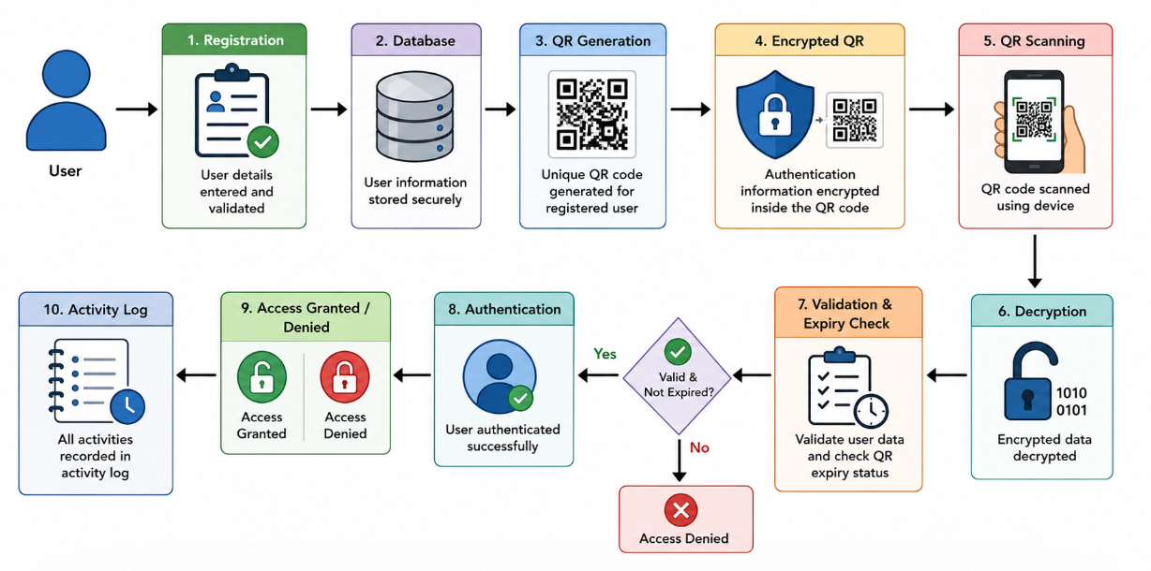

Module 1: User Registration
The user enters the required registration information. The system validates the input and stores the information in the database. A unique user identity is created for each registered user.

Module 2: QR Code Generation
After successful registration, the system generates a unique QR code associated with the user. Authentication information is protected before being encoded into the QR code.

Module 3: Encrypted QR Verification
During authentication, the QR code is scanned. The system extracts the encoded information, decrypts it, verifies the user information, and checks the QR code expiry status.

Module 4: Login Authentication and Activity Log
If verification is successful, access is granted to the registered user. If verification fails, access is denied. The system records login, failed authentication, and logout activities.

Systems Approach
The four modules operate as an integrated system. User Registration provides the identity information required by QR Code Generation. The generated QR code is later processed by the Encrypted QR Verification module. The verification result is passed to the Login Authentication module, which determines whether access should be granted. Authentication events are finally stored in the Activity Log for monitoring.

3.6 Trade-off Analysis
Design Decision | Alternative Considered | Benefit | Disadvantage | Final Decision & Justification
QR authentication | Password | Reduces password dependency | Requires QR scanning | QR selected for convenience
Encryption | Plain QR data | Protects authentication information | Adds processing complexity | Encryption selected
Expiry | Permanent QR | Permanent access | Higher misuse risk | Expiry selected
Activity logging | No logging | Better monitoring | Requires additional storage | Logging selected

3.7 Sustainability, Ethics, Safety, Risk & Security
Domain | Consideration | Evidence Evaluated | Impact on Final Decision
Sustainability | Minimize hardware dependency | Software-based authentication | Software solution selected
Ethics | Protect user information | Data handling and access control | Only required information is processed
Health & Safety | Avoid unsafe physical requirements | QR scanning through normal devices | No specialized physical equipment required
Security | Prevent unauthorized access | Encryption, validation, expiry checking and logs | Integrated security mechanisms selected

Security Measures
- User input validation.
- Protected authentication information.
- Encryption of QR-related information.
- QR validity checking.
- QR expiry checking.
- Access denial for invalid authentication.
- Failed-attempt logging.
- Logout/session management.
- Restricted access to stored information.

Risk Register
Risk | Likelihood | Severity | Risk Level | Mitigation | Residual Risk
QR code copied | Medium | High | High | Encryption and expiry checking | Medium
Invalid QR scanned | High | Medium | High | QR validation | Low
Unauthorized | Medium | High | High | Authentication | Medium
User data exposure | Low | High | Medium | Secure data handling | Low
QR scanning failure | Medium | Low | Low | Clear QR generation and rescanning | Low
CHAPTER 4 IMPLEMENTATION, TESTING & RESULTS, PROJECT MANAGEMENT
4.1 Development Approach & Resources
The system is developed using a modular software development approach. Module 3 focuses on encrypted QR verification, where the QR code is scanned, decrypted, checked for expiry, and validated before authentication. The module is implemented and tested independently before integration with the complete authentication system. Testing is performed using valid, invalid, expired, and modified QR codes to evaluate the reliability and security of the verification process.
Table 4.1 lists the principal resources and technologies used in the development and testing of Module 3.
Resource / Technology | Purpose
Computer | Development and testing
Python | Application development
QR Code Library | QR generation and processing
Encryption Library | Encryption and decryption of QR information
QR Scanner / Camera | QR code scanning
Database | Storage of registered information
Code Editor / IDE | Development and debugging
Web Interface | User interaction and verification
4.2 Hardware / Software Implementation & Modern Tools Used
Encrypted QR Verification Implementation
The encrypted QR verification module is responsible for securely validating the QR code presented by the user. The QR code contains protected authentication information that cannot be directly used without decryption.
QR Code Scanning
The scanner or camera captures the QR code presented by the user. The system extracts the encrypted information from the scanned QR code for further processing.
QR Decryption
After scanning, the encrypted information is decrypted using the implemented encryption mechanism. The decrypted information is then prepared for validation against the registered user information.
Expiry Validation
The system checks the expiry information associated with the QR code. If the QR code has expired, the verification process is stopped and access is denied.
QR Validation
The decrypted information is compared with the registered information. The QR code is considered valid only when the required information matches and the QR code has not expired.
Verification Result
The system provides the verification result based on the QR code status:
- Valid QR code – verification successful.
- Invalid QR code – verification rejected.
- Expired QR code – access denied.
- Modified QR code – verification fails.
Tool / Software / Component | Purpose | Stage Used
Python | Main application development | Development
QR Code Library | QR scanning and processing | Development
Encryption Library | Encryption and decryption | Development
Database | Registered information storage | Development
IDE / Code Editor | Coding and debugging | Development
QR Scanner | QR code input | Testing
Test Cases | Verification testing | Testing
4.3 Test Plan & Verification
Table 4.3 defines the test cases used to verify the functional behaviour of the encrypted QR verification module.
Requirement | Test Method | Acceptance Criterion
QR scanning | Scan a valid QR code | QR code detected successfully
QR decryption | Scan an encrypted QR code | Information decrypted successfully
Valid QR | Scan valid QR code | Verification succeeds
Invalid QR | Scan unrelated QR code | Verification rejected
Expired QR | Scan expired QR code | Access denied
Modified QR | Change QR information and scan | Verification fails
Incorrect encrypted data | Scan incorrect encrypted QR | Verification rejected
QR validation | Compare decrypted data with registered data | Matching information accepted
Authentication | Use valid verified QR | Access granted
Failed verification | Use invalid or expired QR | Access denied
Table 4.4 records the verification status against each specification.
Specification | Required Value | Achieved Value | Status
QR scanning | QR detected | QR detected | Pass
QR decryption | Data decrypted | Data decrypted | Pass
Valid QR verification | Access granted | Access granted | Pass
Invalid QR verification | Access denied | Access denied | Pass
Expired QR verification | Access denied | Access denied | Pass
Modified QR verification | Verification fails | Verification fails | Pass
QR validation | Correct data validated | Correct data validated | Pass
Authentication | Access granted | Access granted | Pass
4.4 Results
The implemented Module 3 demonstrates the encrypted QR verification process from scanning to final validation. The system scans the QR code and extracts the encrypted authentication information.
The extracted information is decrypted and validated against the registered information. The system also checks the expiry status of the QR code before allowing authentication.
Valid QR codes are successfully verified, while invalid, expired, or modified QR codes are rejected. The testing process confirms the major functional requirements of QR scanning, decryption, expiry checking, and validation.
Suggested Results to Present
- QR code scanning screenshot.
- Encrypted QR code screenshot.
- Decryption process screenshot.
- Valid QR verification screenshot.
- Invalid QR verification screenshot.
- Expired QR verification screenshot.
- Modified QR verification screenshot.
- Test-case result table.
- QR verification success/failure chart.
4.5 Data Analysis & Engineering Judgment
The testing process is used to evaluate whether the encrypted QR verification module satisfies its functional and security requirements. The verification process ensures that only valid and non-expired QR codes are accepted.
Encryption provides protection to the information stored within the QR code. Decryption allows the system to retrieve the protected information for validation. Expiry checking prevents the use of outdated QR codes.
The comparison of decrypted information with registered information helps identify invalid or modified QR codes. Therefore, the combination of encryption, decryption, expiry checking, and validation provides a more secure QR-based authentication process.
From an engineering perspective, the main consideration is maintaining a balance between security and usability. Additional verification steps improve security but may increase the processing required during authentication.
If QR scanning fails, possible causes include poor image quality, insufficient lighting, incorrect QR size, or camera limitations. Therefore, clear QR generation and suitable scanning conditions are important for reliable verification.
4.6 Comparison with Existing Solutions & Achievement of Objectives
Objective | Evidence | Achievement
Scan QR code | QR scanning module | Fully Achieved
Protect QR information | Encryption mechanism | Fully Achieved
Decrypt QR information | Decryption mechanism | Fully Achieved
Verify QR codes | Verification module | Fully Achieved
Check QR expiry | Expiry validation | Fully Achieved
Validate QR information | Data comparison | Fully Achieved
Reject invalid QR | Invalid QR test case | Fully Achieved
Reject expired QR | Expired QR test case | Fully Achieved
Test the verification module | Test cases | Fully Achieved
The objectives listed above are evaluated based on the results obtained during testing. The encrypted QR verification module successfully performs scanning, decryption, expiry checking, and validation.
4.7 Strengths & Limitations
Strengths
● Secure protection of authentication information using encryption.
● QR-based verification provides a simple authentication mechanism.
● Expiry checking prevents the use of outdated QR codes.
● Validation helps identify invalid or modified QR information.
● The testing process covers valid, invalid, expired, and modified QR codes.
● The modular design allows the QR verification process to be tested independently.
Limitations
● QR scanning performance depends on camera quality and lighting conditions.
● The system depends on the availability of the required encryption and QR processing libraries.
● The current system is implemented as a prototype and requires further testing for large-scale deployment.
● Stronger security mechanisms may be required before real-world deployment.
● The verification process may be affected by damaged or unclear QR codes.
4.8 Project Planning, Roles & Budget
Phase | Activity
Phase 1 | Problem identification
Phase 2 | Literature review
Phase 3 | System architecture and design
Phase 4 | User registration development
Phase 5 | QR generation development
Phase 6 | Encrypted QR verification development
Phase 7 | QR scanning, decryption and expiry validation
Phase 8 | Integration and testing
Phase 9 | Results and analysis
Phase 10 | Report preparation and final review

Team Roles
Student | Assigned Responsibility | Actual Contribution
Elakati Renu Sree (192511035) | User Registration | Introduction, Module 1, Results
Tarunika S (192511024) | QR Code Generation | Problem Statement, Module 2, Conclusion
R Sweta (192511408) | Encrypted QR Verification | Literature Review, Module 3, Testing
Abinaya (19241161) | Login Authentication & Activity Log | Objectives, Module 4, Future Scope

Individual Contribution Percentage
Student | Contribution
Elakati Renu Sree (192511035) | 25%
Tarunika S (192511024) | 25%
R Sweta (192511408) | 25%
Abinaya (19241161) | 25%
Total | 100%

CHAPTER 5 CONCLUSION, FUTURE WORK AND REFLECTION

5.1 Conclusion
The QR Code-Based Secure Authentication System was designed to provide a secure and convenient alternative to traditional password-based authentication. The system integrates user registration, QR code generation, encrypted QR verification, login authentication, and activity logging into a single authentication workflow.
The proposed system verifies QR information before granting access and rejects invalid or expired authentication data. Encryption provides protection for authentication information, while activity logging enables monitoring of authentication events. The modular design allows each function to be developed and tested independently before integration.
The project demonstrates that QR codes can be effectively combined with encryption, validation, expiry checking, and access-control mechanisms to develop a practical authentication solution. The system provides a good balance between usability, security, and implementation simplicity.

5.2 Future Work
The system can be further improved through the following enhancements:
- Integration of biometric authentication.
- Combination of QR authentication with OTP-based multi-factor authentication.
- Development of a dedicated Android/iOS application.
- Cloud-based user and authentication management.
- Real-time alerts for suspicious login attempts.
- Automatic QR regeneration after a defined period.
- Advanced protection against QR code copying.
- Integration with institutional authentication systems.
- Role-based access control.
- Advanced security analytics for activity logs.
- Secure cloud backup and recovery.
- Hardware security support for highly sensitive applications.

5.3 Professional Learning & Individual Reflection

New Knowledge Acquired
• QR code generation and processing.
• Authentication system design.
• Encryption and secure data handling.
• Database-based user management.
• Authentication testing.
• Activity log implementation.
• Security risk identification.

Engineering & Professional Skills Developed
• Software development.
• System architecture design.
• Debugging.
• Testing and verification.
• Teamwork.
• Technical documentation.
• Problem solving.
• Engineering decision making.
• Presentation and communication.

Elakati Renu Sree – Individual Reflection
The most difficult part of my contribution was designing the user registration process so that the entered information was correctly validated and connected with the QR authentication workflow. I learned that proper input validation is important because incorrect user data can affect later authentication. I also learned how registration information is stored and used by other modules. If the project were repeated, I would improve the registration interface and add stronger validation and user feedback mechanisms.

Tarunika S – Individual Reflection
My major contribution was the QR code generation module. The main challenge was ensuring that each registered user received an appropriate unique QR code. I learned how QR data can be generated and connected with user information. I also understood the importance of QR readability during authentication. If the project were repeated, I would improve QR generation and provide automatic regeneration when required.

R Sweta – Individual Reflection
My contribution focused on encrypted QR verification. The main challenge was understanding how QR information could be protected and then verified during scanning. I learned about encryption, decryption, validation, and expiry checking. The important engineering decision was to verify the QR information before granting access. If the project were repeated, I would strengthen key management and introduce additional security mechanisms.

Abinaya – Individual Reflection
My contribution focused on login authentication and activity logging. The major challenge was connecting the QR verification result with the final access decision and maintaining correct activity records. I learned how successful and failed authentication attempts can be recorded for monitoring. I also gained knowledge about session management and access control. If the project were repeated, I would improve the activity dashboard and introduce real-time security notifications.

REFERENCES
The final report should use one consistent IEEE referencing style. The following are suitable starting references for this project:
[1] International Organization for Standardization, ISO/IEC 27001:2022 – Information Security, Cybersecurity and Privacy Protection – Information Security Management Systems – Requirements, ISO, 2022.
[2] International Organization for Standardization, ISO/IEC 27002:2022 – Information Security, Cybersecurity and Privacy Protection – Information Security Controls, ISO, 2022.
[3] International Organization for Standardization, ISO/IEC 18004 – Information Technology – Automatic Identification and Data Capture Techniques – QR Code Bar Code Symbology Specification, ISO.
[4] OWASP Foundation, OWASP Application Security Verification Standard, OWASP.
[5] W. Stallings, Cryptography and Network Security: Principles and Practice, Pearson.

APPENDICES

Appendix A — Detailed Calculations

Appendix A – Detailed Calculations
Include relevant calculations such as:
- QR data size calculations, if applicable.
- Authentication response-time calculations.
- Test success percentage.
- Error percentage.
- Performance measurements.
- Any encryption-related calculations used in the implementation.

Test Success Percentage
If the actual test contains N total test cases and P passed cases:
Test Success (%) = (P / N) × 100
Use the actual values obtained from your testing.

Appendix B — Engineering Drawings / Schematics

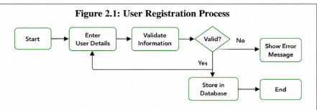

Appendix C — Source Code / Code Repository Information
Include the project source code or approved repository information.
Suggested folder structure:
QR-Secure-Authentication/
│
├── registration/
├── qr_generation/
├── qr_verification/
├── authentication/
├── activity_log/
├── database/
├── testing/
├── screenshots/
└── README.md

Appendix D — Datasheets
Not applicable to this project, as no hardware components were used.

Appendix E — Experimental / Raw Data
• Test case records.
• Successful authentication results.
• Failed authentication results.
• Invalid QR test results.
• Expired QR test results.
• Authentication response times.
• Activity log records.

Appendix F — Ethics / Institutional Approval

The project should follow responsible handling of user information. Only required user data should be collected and used for authentication. Authentication information should be protected from unauthorized access, and project testing should avoid exposing real personal information.

Appendix G — Project Meeting / Progress Records

Review 1 on 27/7/2026

During the first review, we explained and presented our proposed project topic, its objectives, and the overall concept of the system.

The review panel suggested making necessary changes to the system architecture to improve the clarity and functionality of the proposed system.

Based on the feedback, we revised the architecture and proceeded with the implementation of the system.

Review 2 on 28/8/2026

During the second review, we presented the changes made to the system architecture based on the feedback received during the first review.

We also demonstrated the implementation progress and working modules of the system. The implemented features and overall system functionality were explained to the review panel.

Appendix H — User / Industry Feedback
Not applicable / not collected for this prototype.

Appendix I — Publications / Patents / Competitions / Product Outcomes
None reported.

Appendix J — Individual Contribution Evidence
Review Photos:

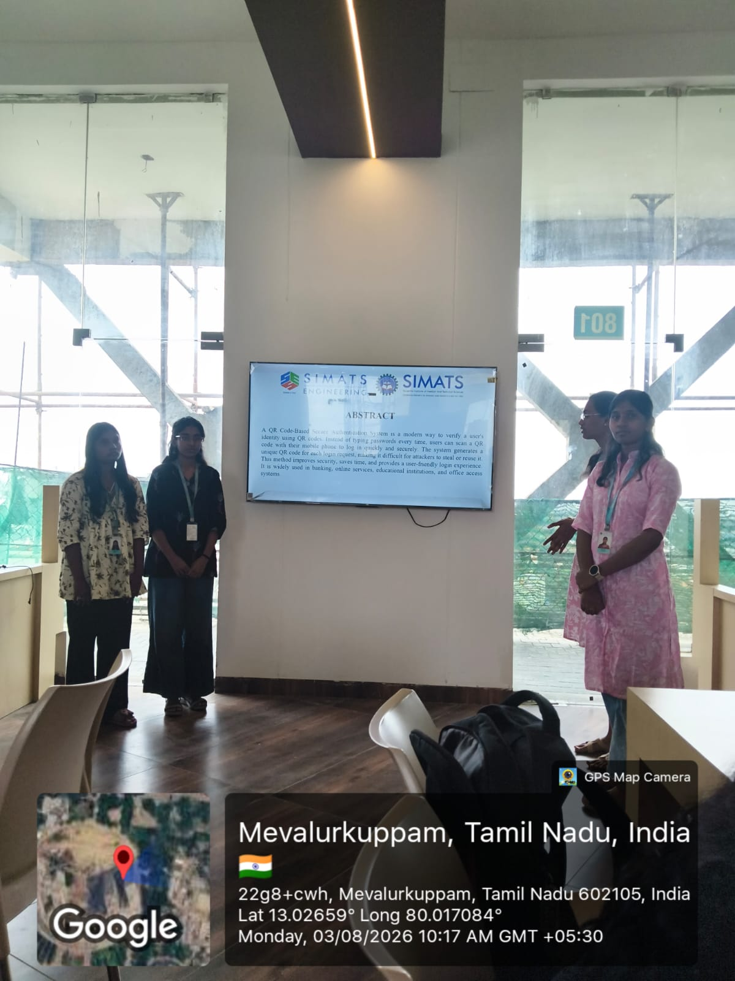

CAPSTONE PROJECT OUTCOME MAPPING SHEET

Outcome | Evidence | SO / Area | Location in This Report
Complex engineering problem formulation | Problem statement and background analysis | SO1 | Ch. 1, Ch. 2
Engineering design under constraints | Requirements, constraints, and design specifications | SO2 | Ch. 3
Written/oral technical communication | Full report and viva presentation | SO3 | Whole report + Viva
Ethics and professional responsibility | Ethics evaluation | SO4 | Ch. 3 (3.7)
Teamwork and leadership | Team roles and contribution table | SO5 | Ch. 4 (4.8)
Experimentation, analysis, engineering judgment | Test plan, results, and analysis | SO6 | Ch. 4 (4.3–4.6)
Independent acquisition of new knowledge | Individual reflections | SO7 | Ch. 5 (5.3)
Standards | Constraints and applicable standards table | SO2 | Ch. 3 (3.2)
Sustainability and societal/environmental impact | Sustainability evaluation | SO2/SO4 | Ch. 3 (3.7)
Risk assessment and mitigation | Risk register | SO2/SO4 | Ch. 3 (3.7)
Security considerations | Security evaluation | Relevant SO | Ch. 3 (3.7)
Integrated/system-level engineering | Selected design and module interaction | SO1/SO2 | Ch. 3 (3.5)
Project planning and management | Timeline and roles table | SO5 | Ch. 4 (4.8)
Individual contribution | Contribution statement and Ch. 4 (4.8) | SO1–SO7 | Contribution Statement + Ch. 4 (4.8)

